COLLEAGUE WELLBEING STRATEGY

Our goal and principles

Company Name are committed to establishing an interdependent, safe and healthy working culture for all colleagues as a strategic value and recognise that colleague engagement and wellbeing is critical to achieving this.

Health and wellbeing can be defined as a ‘positive state of mind and body, feeling safe and able to cope, with a sense of connection with people, communities and the wider environment.’

Our Colleague wellbeing strategy aims;

- To promote a range of health and wellbeing activities which focus on physical, mental and social health.
- Whilst empowering colleagues to take personal responsibility for maintaining and improving their own wellbeing.

All actions developed as part of this strategy and local site based action plans will meet the following principles as recommended by the World Health Organisation (WHO);

- Accessible to all colleagues – we will take into account how all groups of colleagues can access health and wellbeing initiatives;
- Needs based – All colleagues needs to be identified via My Voice survey and feedback, ECF feedback and health and wellbeing surveys;
- Evidence based – Activities will be based on available research;
- Empowerment – Activities will be designed to ensure that colleagues feel empowered to take control and make their own decisions on their own health and wellbeing;
- Participation – All colleagues will have the opportunity to be involved in developing and taking part in wellbeing activities and campaigns.

Why is it important?

There is a significant amount of evidence to support that improving workplace health and wellbeing has significant benefits for both individual colleagues and the business overall.
These include;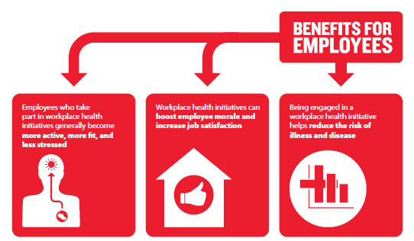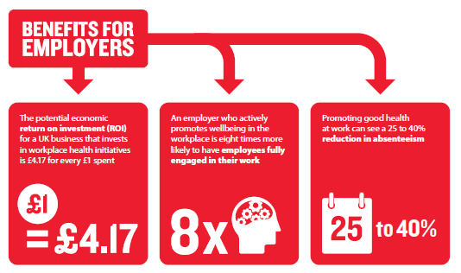

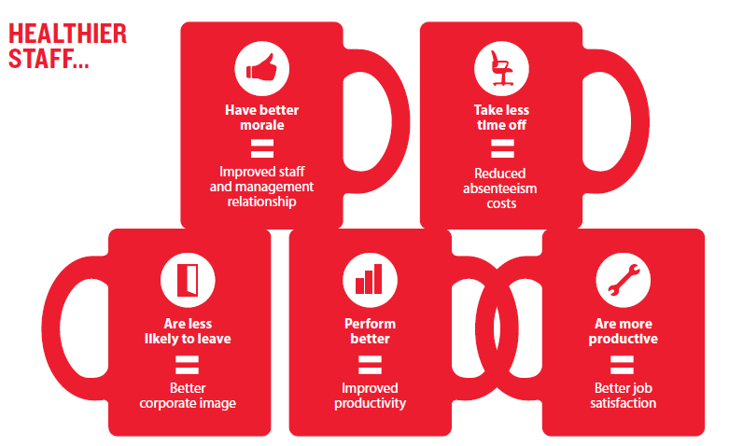

Our starting point

Company Name offer a wide variety of policies and practices to support several aspects of Colleague health and wellbeing. These include;

- Employee Assistance Programme (EAP)
- Mental Health and Wellbeing Policy
- Mental Health First Aid Training provision for line managers
- Occupational Health provision
- Appraisals and Personal Development Plans
- Display Screen Equipment training and assessments
- Rehabilitation service (Zurich)
- Pre-retirement wind down programme
- Childcare vouchers
- Absence management policies
- Recognition schemes
- Engagement Survey (My Voice) and action plan
- Cycle to work scheme
- Various activities and challenges, examples include ‘Get the World Moving,’ ‘Tough Mudder’ and ‘Welsh 3 Peaks challenge.’

Alongside this, local sites also undertake various activities, health challenges and campaigns throughout the year.

Our approach

Our approach to developing a wellbeing culture will be based on a combination of co-ordinated UK campaigns (3 a year) alongside local action plans. In order to determine the priorities for local action plans, the Workplace Wellbeing Charter (2018) will be used as a basis.

The Workplace Wellbeing Charter is a national standard for best practice in workplace health, safety and wellbeing and covers 8 standards as follows;

1) Leadership
2) Absence Management
3) Health and Safety
4) Mental Health
5) Smoking
6) Physical Activity
7) Healthy Eating
8) Alcohol.

Each standard has 3 levels where an organisation can score; Commitment level, Achievement level and Excellence level.

To enable a needs based action plan to be developed, a site self-assessment (available on the Workplace Wellbeing website) should be undertaken, alongside a colleague wellbeing survey. This data, combined with results from the My Voice Survey and absence statistics will support the formulation of local priorities and subsequent action plan. An action plan template is available in appendix 1. It is recommended that sites choose up to 3 priorities per annum.

In order to engage colleagues in the development of the local priorities and action plan, it is important that it is developed, monitored and reviewed with full colleague involvement, ideally by site based Wellbeing Champions whose role is to;

- Be a point of contact for colleagues who wish to engage in workplace wellbeing activities;
- Represent colleagues at meetings about health and wellbeing;
- Set up regular workplace activities and campaigns;
- Give colleagues up to date information on where they can access local services;
- Establish and maintain colleague health and wellbeing noticeboards;
- Communicate colleague health and wellbeing updates in team meetings;
- Collect feedback and requests from colleagues about colleague wellbeing matters and raise them with appropriate management, ensuring feedback is provided where appropriate.

A template for seeking interest in Wellbeing Champions is included in appendix 2.

Sites may wish to consider setting up a specific project group to undertake the work in this area, such as a Health and Wellbeing steering group or could chose to combine it with an existing colleague group such as the health and safety committee, an employee communications forum, a My Voice Group or similar.

Communications

A range of communications methods will be used to ensure awareness and access by all Colleagues including

- Colleague health and wellbeing emails
- Colleague health and wellbeing noticeboards
- Strategy and action plan updates at relevant meetings such as colleague communication forums/ My Voice meetings/ health and safety committee.
- Updates from site based Wellbeing champions at site briefs.

Review

The colleague wellbeing strategy and site based action plans will be reviewed on an annual basis to ensure they are aligned with business needs or sooner if appropriate. Measurement of success against the local priorities will be via repeat self-assessment against the Workplace Wellbeing Charter.

Appendix 1 – Template Wellbeing action plan

COLLEAGUE WELLBEING ACTION PLAN 2018-2021

Standard name and level
Criteria | Action | Who | When | Status update

Appendix 2 – Template Wellbeing champion notice

staff notice

Health & Wellbeing Champions needed!

As you are aware following the recent site briefs, we are looking to recruit individuals who are passionate about colleague’s wellbeing to become Health & Wellbeing Champions for the [location] site. Health & Wellbeing Champions will form a subgroup from the My Voice Committee and the Health and Safety Committee and therefore will attend regular meetings representing their team to discuss and implement the wellbeing strategy and put forward ideas to improve colleague wellbeing.

As a Health & Wellbeing Champion your role would be;

- Be a point of contact for colleagues who wish to engage in workplace wellbeing activities;
- Represent colleagues at meetings about health and wellbeing;
- Set up regular workplace activities and campaigns;
- Give colleagues up to date information on where they can access local services;
- Keep colleague health and wellbeing noticeboards up to date;
- Communicate colleague health and wellbeing updates in their team meetings;
- Collect feedback and requests from colleagues about colleague wellbeing matters and raise them with appropriate management, ensuring feedback is provided where appropriate.

If you are interested in joining the committee please contact [name], [contact details] by [date].

Please note that full training and reasonable time to attend meetings and carry out the role will be provided. Please ensure that your line manager is aware of your desire to be considered for this role.

Department of Health (2009)
World Health Organisation (2003)
British Heart Foundation (2018)
https://www.wellbeingcharter.org.uk

